Project Design Phase-II
Data Flow Diagrams & User Stories
Date | Team ID | Project Name | Maximum Marks
7 October 2026 |  | Car Rental Request Automation in ServiceNow | 4 Marks

Data Flow Diagrams
A Data Flow Diagram (DFD) shows how information moves through a system: where data comes in and goes out, which processes transform it, and where it is stored.
DFD Level 0 / Level 1 – Car Rental Request Automation
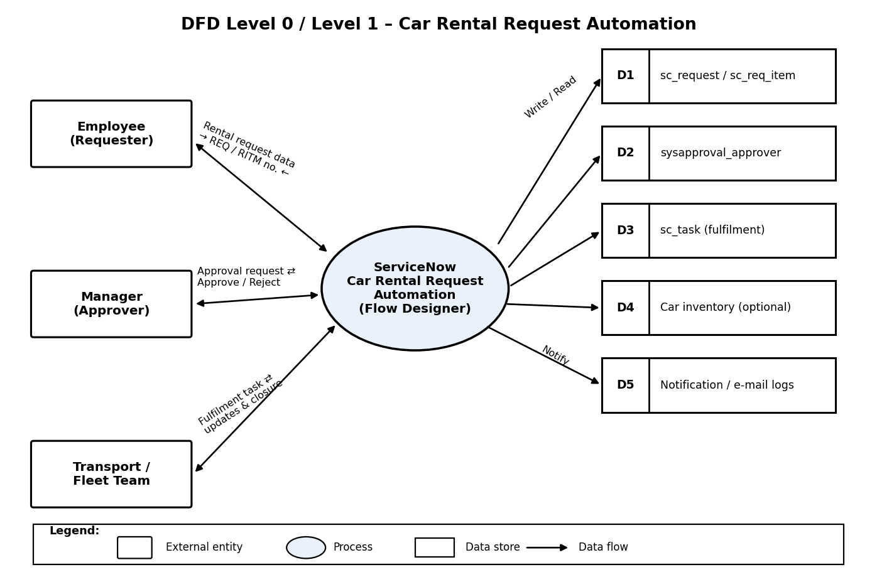
External Entities and Main Data Flows
- Employee (requester) sends the car rental request data: dates, locations, car type and reason.
- Manager is sent an approval request and sends back an Approve or Reject decision.
- Transport / Fleet team is sent a fulfillment task and returns the car assignment and task status.
- The ServiceNow platform (central process) creates the REQ, RITM, SCTASK and approval records and triggers notifications.
- The notification engine delivers email and portal messages to everyone involved.
Core Data Stores
- D1: sc_request / sc_req_item (REQ and RITM) – request header and item details
- D2: sysapproval_approver – approval records and decisions
- D3: sc_task – fulfillment tasks for the Transport team
- D4: custom Car Inventory table (optional) – vehicles, their status and assignment history
- D5: sys_email / notification logs – record of all communication
DFD Level 1 – Major Processes
- P1 – Submit catalog request: the employee completes the variables, creating a REQ and RITM.
- P2 – Route for approval: Flow Designer raises an approval record and the manager decides.
- P3 – Create fulfillment task: once approved, an SCTASK is assigned to the Transport group.
- P4 – Fulfill and close: Transport updates the task, the RITM and REQ close, and notifications go out.
- P5 – Notify stakeholders: sent at every state change (submission, approval, rejection, closure).
User Stories
User stories for the Car Rental Request Automation product.
User type | Epic | USN | User story / task | Acceptance criteria | Priority | Release
Employee | Catalog request | USN-1 | As an employee, I can open the “Car Rental Request” catalog item and submit a request with travel date, pick-up and drop-off locations, duration, car type and reason. | A REQ and RITM are created and a request number is displayed. | High | Sprint-1
 |  | USN-2 | As an employee, I get an email or portal notification confirming that my request was submitted. | Notification arrives with the request number and a summary. | High | Sprint-1
 | Status tracking | USN-3 | As an employee, I can check the current status of my request in My Requests or the Service Portal. | Status and activity stream are shown and kept current. | High | Sprint-1
 |  | USN-4 | As an employee, I am notified when my request is approved, rejected or completed. | Correct message is sent, with the reason if rejected or next steps if approved. | High | Sprint-1
Manager | Approval | USN-5 | As a manager, I am notified of a pending request and can approve or reject it, adding comments if I wish. | Approval record is updated; the request moves forward or is cancelled. | High | Sprint-1
 |  | USN-6 | As a manager, I can see the main request details (dates, locations, car type, reason) on the approval form. | All relevant variables appear on the approval screen. | Medium | Sprint-1
Transport team | Fulfillment | USN-7 | As a Transport team member, I automatically get an SCTASK when a request is approved. | Task shows in the group queue with correct assignment and variables. | High | Sprint-1
 |  | USN-8 | As a Transport team member, I can update the task (assign a car, add work notes) and close it, which closes the parent request. | Closing the task updates the RITM / REQ state and the requester is notified. | High | Sprint-1
Admin | Configuration & reporting | USN-9 | As an admin, I can capture every configuration change in an Update Set for promotion. | Update Set holds all relevant records and can be committed on the target instance. | High | Sprint-1
 |  | USN-10 | As an admin, I can view reports and dashboards of open requests, cycle times and SLA performance. | Reports can be filtered by department, car type and status, and the data is accurate. | Medium | Sprint-2

Note: every user story maps to a Flow Designer stage, Business Rule or catalog configuration, and is implemented following ServiceNow good practice (Update Sets, ACLs, Flow error handling).

